# Experiment 2

## 1 Key Hypothesis

Suppose people face a sequence of rewards. When the amount of reward offered at one specific time becomes larger, they would pay more attention to it, thus are less sensitive to the amounts offered at other times within the sequence.

Given that the hypothesis asserts that larger rewards can naturally catch more attention, we can term it as "*value-driven attentional capture*". Hickey et al. (2010) and Anderson et al. (2011) found evidence of value-driven attentional capture in visual search.

## 2 Survey Design

### 2.1 Last experiment

In the last experiment, participants were presented with a series of intertemporal choice questions, structured in form of choice lists. Each choice list consists of 10 rows, and in each row, participants have to actively and explicitly choose between a single immediate reward (labelled as "option A") and a two-reward sequence (labelled as "option B"). For instance, in one choice list, the participants may need to choose between

A. receive £100 today or B. receive $X$ today and £50 in 1 month

where $X$ varies from £10 to £100, with a difference of £10 between each row. With $X$ being larger, there will be more people preferring option B over option A. In the last experiment, I propose that if the back-end reward in this option B, i.e. "£50 in 1 month", is assigned with larger quantities (e.g. £50 is increased to £90, or "1 month" is increased to "9 months"), people have less attention to be allocated on the front-end amount $X$. Thus, they will be less sensitive to changes in $X$-- each unit increase in $X$ will on average induce fewer people to shift from option A to option B.

Someone may be interested in what amount of $X$ would make option A and B indifferent to a decision maker ("indifference point"). The fact is, if people are less sensitive to $X$, the indifference point for $X$ would have a larger variance among the participants. I describe the rationale in the document of experimental results. The intuition for this is, when a decision maker is insensitive to $X$, she may feel hard to determine what exact amount of $X$ could make the value of option B precisely equivalent to option A.

### 2.2 Current experiment

In the current experiment, participants will still face a series of choice lists, and each choice is still between a single reward and a two-reward sequence. However, there are four differences in this experiment. First, the single reward option (option A) varies across rows, while the sequence option (option B) is constant within a choice list. Second, participants can "bunch" the choices. When they pick an option in a specific row, all option As below it and all option Bs above it will be automatically selected. So, participants could focus on finding the indifference point. Third, after they select an option in a row, a certain number of rows which were folded between that specific row and the row next to it will show up. The participants then will need to make a choice among these unfolded rows. Fourth, after they complete a choice list, there will be a question asking them to rate how sure (or confident) they are about the choices they just made.

The following is a screenshot for the choice list in this experiment.

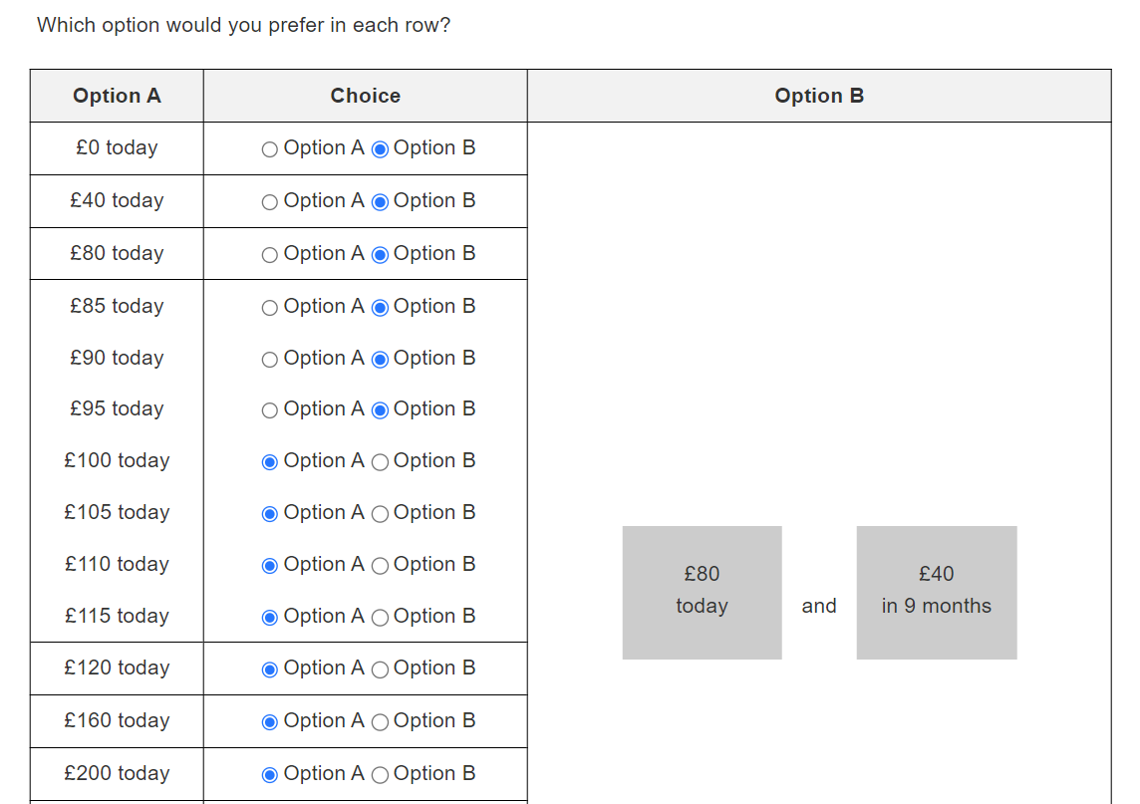

### 2.3 Model Prediction

Suppose a decision maker face a choice between

A. receive $Y$ today or B. receive £80 today and £40 in 9 months

Clearly, the indifference point for $Y$ should be larger than £80 and smaller than £80+£40=£120. Suppose it is £100, which means adding a back-end reward of "£40 in 9 months" is equivalent to adding £20 to the existing front-end amount £80 in option B. If we increase the front-end amount £80 to £160, this front-end reward could catch more attention, thus people should pay less attention to "£40 in 9 months". As a result, adding this back-end reward may be equivalent to adding an amount smaller than £20 to the front-end amount £160.

This argument is consistent with an empirical finding named "front-end amount effect" (Rao and Li, 2011). The front-end amount effect proposes that, suppose the decision maker is indifferent between "receive £10 today" (SS) and "receive £30 in 3 months" (LL). Then, when comparing "receive £510 today" (SS1) and "receive £500 today and £30 in 3 months" (LL1), she would prefer SS1 to LL1. That is, adding a common front-end amount to both options makes the decision maker less patient. Note that, in the latter case, to make SS1 indifferent with LL1, the reward amount in SS1 should become smaller. So, if the front-end amount effect holds true, then argument above should also be true.

However, the impact of attentional capture is not limited to front-end amount. Consider the following choice:

A. receive $Y$ in 9 months or B. receive £80 today and £160 in 9 months

In this choice, option A is aligned with the back-end reward of option B. When the back-end amount in option B increases, people should pay less attention to the front-end amount, so the difference of $Y$ from the back-end amount could become smaller. So far, I have not found a related evidence for the effect about back-end amount.

Now, we can summarize the model predictions with mathematic notation:

Suppose a decision make is indifferent between a single-period reward ("receive $Y$ at time $D$") and a two-reward sequence ("receive $X_{1}$ today and $X_{2}$ in time $T$"). Then, with the others equal,

1. if $D$ is today, for a large enough $X_{1}$, $Y-X_{1}$ may be decreasing in $X_{1}$;
2. if $D=T$, for a large enough $X_{2}$, $Y-X_{2}$ may be decreasing in $X_{2}$.

## 3 Related Theories

### 3.1 Standard Discounted Utility Models

Here we only consider the case of a varying front-end amount. But the same rationale can be applied to the back-end amount case. Let $u\left(.\right)$ be the instantaneous utility function, $u'>0$, $u″<0$. In standard discounted utility models, we can solve the indifference point for $Y$ by:

$$u\left(Y\right)=u\left(X_{1}\right)+δ⋅u\left(X_{2}\right)$$

Fixing the back-end amount (so $X_{2}$ and $δ$ is fixed) and rearranging the equation, we can know that $u\left(Y\right)-u\left(X_{1}\right)$ is fixed. Think of this example: a decision maker is indifferent between receiving £100 today (option A) and receiving £80 today and £40 in 9 months (option B); that is, $X_{1}$ is £80 and the indifference point for $Y$ is £100. If we increase $X_{1}$ by £80, to £160, then due to diminishing marginal utility, we should have $u\left(180\right)-u\left(160\right)<u\left(100\right)-u\left(80\right)$. Thus, when $X_{1}$ is increased by £80, the indifference point for $Y$ should be increased by an amount more than £80. In other words, the standard discounted utility models predict that $Y-X_{1}$ is always increasing in $X_{1}$.

Note that the impact of diminishing marginal utility is contradictory with value-driven attentional capture. Therefore, even if the decision makers are influenced by attentional capture, as long as the influence is not strong enough ( $X_{1}$ do not catch enough attention), $Y-X_{1}$ may still be increasing in $X_{1}$. When $X_{1}$ is small, the impact of diminishing marginal utility may override attentional capture, and thus $Y-X_{1}$ can be increasing in $X_{1}$; only when $X_{1}$ is large enough could we observe a $Y-X_{1}$ being decreasing in $X_{1}$.

### 3.2 Cognitive Uncertainty

In intertemporal choice, one alternative account for people’s insensitivity to changes in a reward sequence could be, they are uncertain about the value of that sequence. This notion is closely related to the term “cognitive uncertainty” in recent literature. Such literature proposes that many decision anomalies can be explained by noisy perception of value (Gabaix and Laibson, 2017; Khaw et al., 2021; Loomes, 2005).

Enke and Graeber (2023) propose that, to measure cognitive uncertainty, one can let participants to rate how sure they are about the choices they made. To test whether cognitive uncertainty has an impact in our experimental decision context, I set such a question after each choice list as well.

Moreover, Frydman and Jin (2021) test a theory of this type, called “efficient coding”, in two risky choice experiments. Insights from their experiment 1 may help explain (but do not directly explain) a phenomenon found in our last experiment. As an illustration, think of a choice between “receive £100 today” (option A) and “receiving $X$ today and £50 in 1 month” (option B). When $X$ is no larger than £50, obviously nobody would choose option B; When $X$ reaches £100, certainly everybody would choose option B. So, the indifference point for $X$ must lie in (£50, £100). If we increase the back-end amount in option B from £50 to £90, the indifferent point should lie in (£10, £100). In the latter case, to find the indifference point for $X$, people have to use the limited cognitive capacity to search through a wider range of numbers; thus, their estimation on the indifferent point could be nosier (so performing a smaller sensitivity to $X$).

By contrast, the insights from Frydman and Jin (2021) may not be applicable to the current experiment. Think of a choice between “receive $Y$ today” (option A) and “receive $X_{1}$ today and £40 in 9 months” (option B). Clearly, the indifference point for $Y- X_{1}$ must lie in (0, £40). Not matter how we change the magnitude of $X_{1}$, as long as the back-end amount in option B does not change, the corresponding indifference point will always lie in this range. Therefore, the current experiment can help us distinguish the attentional capture account and cognitive uncertainty account for what is observed in the last experiment.

## 4 Follow-Up Test

Pachur et al. (2018) propose that the parameters of cumulative prospect theory are associated with attention allocation. They use mouse tracking to measure selective attention. For example, in their experiment 2, they mask the potential outcomes in a risky choice task. Participants are assigned to different groups. In one group, if the participants move mouse over a loss outcome, the outcome will display for 9s; if the participants move mouse over a gain outcome, the outcome will display for 3s. In another group, the display durations are reversed – 9s for a gain outcome and 3s for a loss outcome. The estimated loss aversion coefficient is higher in the former group than in the latter group.

We can apply a similar procedure to our choice list interface (see the screenshot above). That is, we can mask the front-end and back-end rewards in option B. The reward will only display when participants move mouse over it. In one group, the front-end reward displays for a longer duration; in another group, the back-end reward displays for a longer duration. Under this attention manipulation, people in the former group may perform more impatience than those in the latter group.

**Reference**

Anderson, B. A., Laurent, P. A., and Yantis, S. (2011). Value-driven attentional capture. *Proceedings of the National Academy of Sciences*, *108*(25), 10367–10371. https://doi.org/10.1073/pnas.1104047108

Enke, B., and Graeber, T. (2023). Cognitive Uncertainty. *The Quarterly Journal of Economics*, *138*(4), 2021–2067. https://doi.org/10.1093/qje/qjad025

Frydman, C., and Jin, L. J. (2021). Efficient Coding and Risky Choice. *The Quarterly Journal of Economics*, *137*(1), 161–213. https://doi.org/10.1093/qje/qjab031

Gabaix, X., and Laibson, D. (2017). *Myopia and Discounting* (w23254). National Bureau of Economic Research. https://doi.org/10.3386/w23254

Hickey, C., Chelazzi, L., and Theeuwes, J. (2010). Reward Changes Salience in Human Vision via the Anterior Cingulate. *The Journal of Neuroscience*, *30*(33), 11096–11103. https://doi.org/10.1523/JNEUROSCI.1026-10.2010

Khaw, M. W., Li, Z., and Woodford, M. (2021). Cognitive Imprecision and Small-Stakes Risk Aversion. *The Review of Economic Studies*, *88*(4), 1979–2013. https://doi.org/10.1093/restud/rdaa044

Loomes, G. (2005). Modelling the Stochastic Component of Behaviour in Experiments: Some Issues for the Interpretation of Data. *Experimental Economics*, *8*(4), 301–323. https://doi.org/10.1007/s10683-005-5372-9

Pachur, T., Schulte-Mecklenbeck, M., Murphy, R. O., and Hertwig, R. (2018). Prospect theory reflects selective allocation of attention. *Journal of Experimental Psychology: General*, *147*(2), 147–169. https://doi.org/10.1037/xge0000406

Rao, L.-L., and Li, S. (2011). New paradoxes in intertemporal choice. *Judgment and Decision Making*, *6*(2), 122–129. https://doi.org/10.1017/S193029750000406X